Strategic Energy Management Hub

Customer User Guide

|  |
| --- |
| January, 2019 Version 1.0 |

Table of Contents

Introduction 3

Existing Users 4

New Users 6

Navigating the SEM Hub 8

Starting a Project 11

Need Help? 12

Introduction

What is the SEM Hub?

The Strategic Energy Management (SEM) Hub is your one-stop shop to manage your portfolio of BC Hydro business accounts in one easy location. The SEM Hub allows you to:

* Review your historical consumption trends to determine how your buildings are performing against historical trends.
* Start an incentive application to reduce your capital payback and save annually on operational costs
* Review your daily consumption patterns with our Anomaly Detection to see if your systems are operating efficiently and determine quick and simple solutions to save energy
* Determine if the energy efficient project implemented is realizing the savings using Advanced Analytic tools

Existing Users

If you have already registered for the Business Energy Saving Incentive (BESI) Program or the Self-Serve Incentive Program (SIP) and are logging into the SEM Hub for the first time, you may use your existing BESI or SIP login.

1. Go to the SEM Hub main page: <https://app.bchydro.com/semhub>
2. Log in using using your existing BESI or SIP User ID/Password
3. If you have not logged in recently, you may be prompted to change your User ID to your current email address

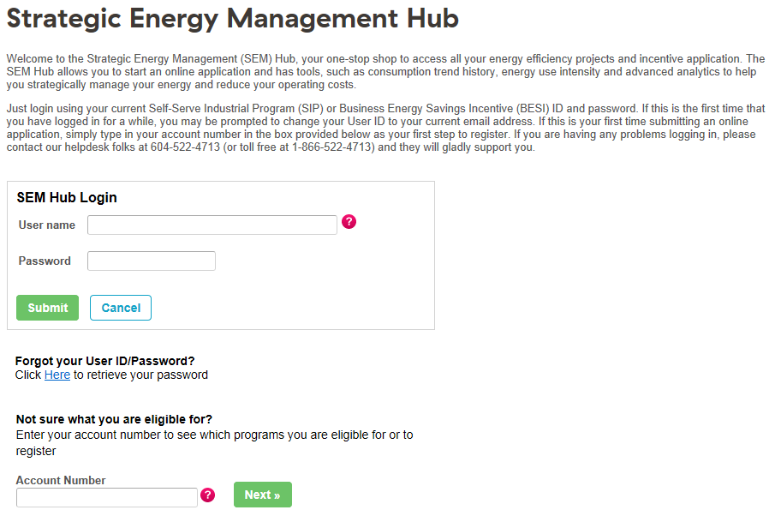

Forget Your User ID / Password?

If you have forgotten either your User ID or Password, call the Energy Savings Business Helpdesk at 604-522-4713 or 1-866-522-4713 to retrieve this information. Your password can also be recovered online.

1. Navigate to “Forgot your User ID/Password” and click “Here” to retrieve
2. Enter the BC Hydro account number and email address which you registered with
3. Click “Retrieve Password”
4. Your User ID/Password will be emailed to you



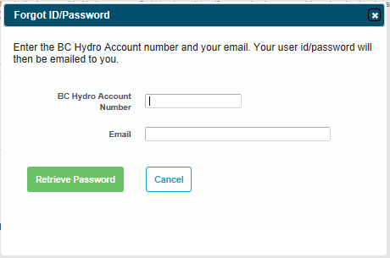

New Users

If you are new to the SEM Hub, you will need to register and create an account:

1. Go to the SEM Hub main page: <https://app.bchydro.com/semhub>
2. Enter your BC Hydro account number, click “Next”
3. A pop up screen will indicate which program your business is eligible for. If you have a Key Account Manager, click on the link for additional information or contact them directly for assistance.
4. Once you have reviewed the information , select “click here” to register

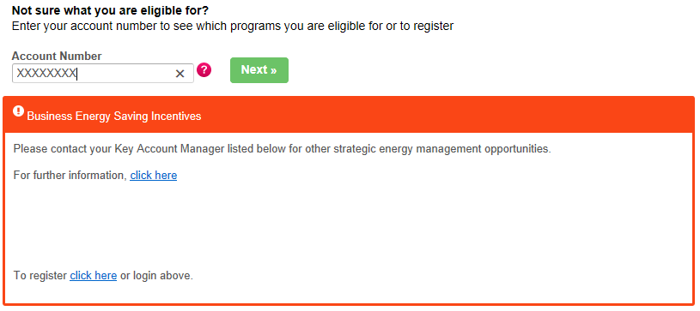

1. After you click on the registration link, your company information will automatically populate.  
   If you receive an error message indicating that you have already registered, or are prompted to an unfamiliar screen, please call the Business Energy Savings Helpdesk for assistance.
2. Fill in or update any fields with the correct information

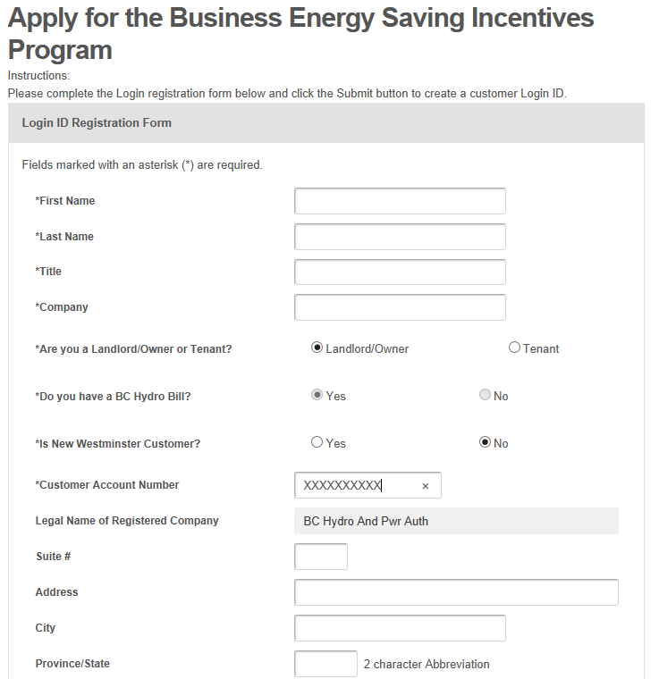

ABC Company

1. Enter a username (valid email address) and password
2. Click “Create New User”

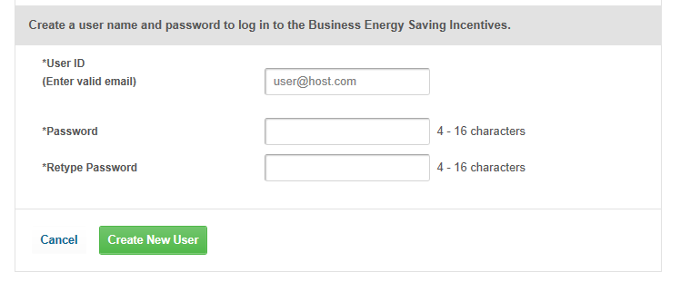

1. Your username and password will be emailed to you.

Navigating the SEM Hub

1. Go to the SEM Hub main page: <https://app.bchydro.com/semhub>
2. Log in using your User ID/Password
3. Once logged in, you will see your company name and a list of potential activities. If there are other sub-companies listed under your company, they will also be visible. Companies will be listed in alphabetical order.
4. Under each company is a summary of activities listed in four groups
   1. Energy Management: Any energy management activities, such as an Energy Manager.
   2. Study: Any funding provided for an energy study.
   3. Projects: All energy saving projects
   4. Proposal: Any active proposals submitted by a registered Alliance of Energy Professionals.
5. If you click ‘Expand All’ additional information is listed for each of the menu options, providing an overview of initiatives for the specific company selected.

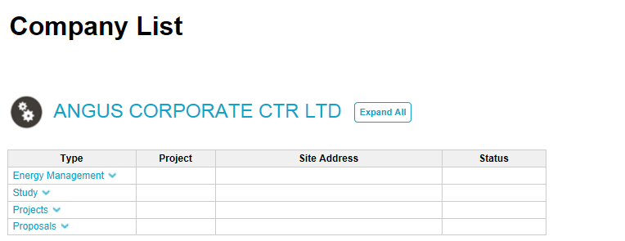

123 COMPANY

If you click on a PSPX project number that corresponds to an online application, you will open the application and will be able to track the progress, make any revisions or move forward the application when necessary. For any custom applications, it will provide you a summary table of the project with key information.

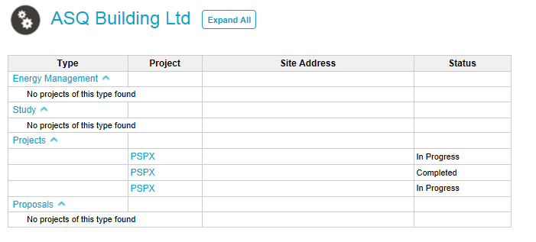

XYZ COMPANY

You can also click on a company name that will open up a more detailed profile and provide all the associated accounts under the company name. The information provides users with a high level summary of all the accounts.

Clicking “Change Company” will take you back to the main menu

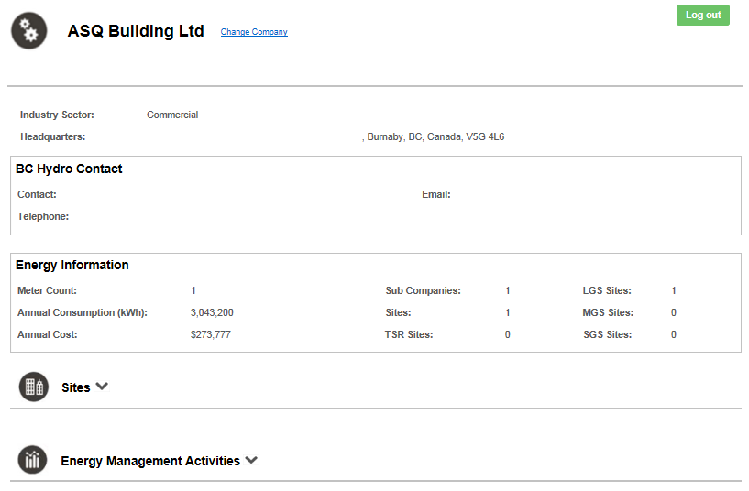

XYZ COMPANY

To explore each company site, the annual consumption and cost, click “Expand All”

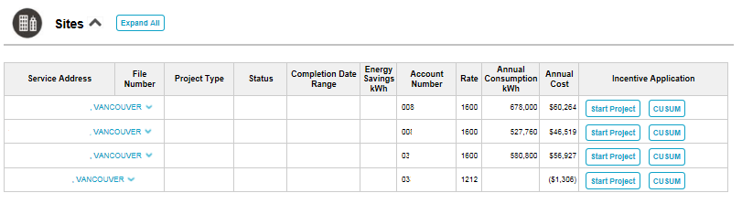

To view any projects related a specific site, click on the site drop down arrow and click on the File number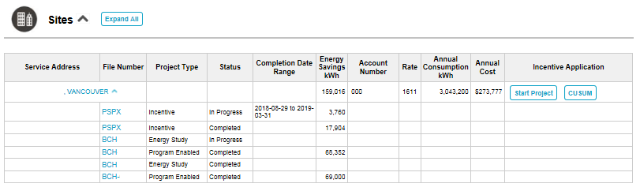

If you wish to start a Business Energy Saving Incentive project, click on “Start Project”

Expanding the Energy Management Activities section provides an annual view of projects and energy savings

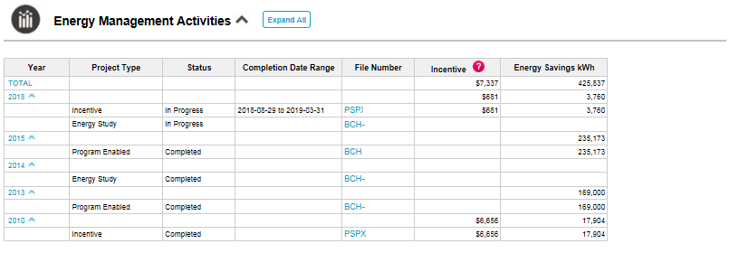

Starting a Project

1. Go to the SEM Hub main page: <https://app.bchydro.com/semhub>
2. Log in using your User ID/Password
3. Click on the company name to go to the profile page.



1. From the main company profile page, navigate down to the Sites menu



**XYZ COMPANY**

1. Expand the menu and look for the service address of the site. Click on “Start Project” 
2. A pop up window will provide you with two options for BESI applications. Select the appropriate option and begin your application.
   1. New incentive application
   2. New application to add lighting controls to a closed BESI project
   3. Simply fill out the online application form to submit an incentive application.

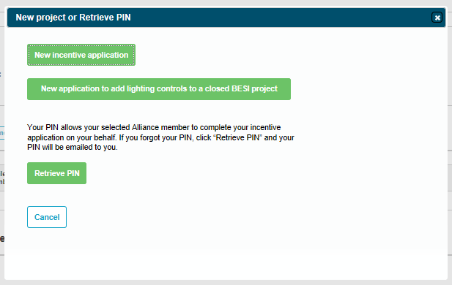

Need Help?

If you need assistance, please contact our Business Energy Savings Helpdesk:

* Email: [incentives@bchydro.com](mailto:%20incentives@bchydro.com)
* Lower Mainland: 604.522.4713
* Toll Free: 1.866.522.4713

Please refer to the BESI or SIP User Guide to submit an application:

[BESI Customer User Guide](http://www.bchydro.com/content/dam/BCHydro/customer-portal/documents/power-smart/business/programs/power-smart-partner-express-customer-user-guide.pdf)

[SIP Customer User Guide](https://app.bchydro.com/SIP/ExternalDocs/SIPCustomerUserGuide.pdf)